# Game Design Document

## PRCO304 – Final Adventure

Bayesian’s Probability Controlled Artificial Intelligence in a Traditional Turn Based Strategy Game

GDD Written by: Daniel Bendell

Table of Contents

Overview 4

Theme 4

Core Gameplay/Mechanics 4

Character Selection 4

Strategic Battle Formations 5

Global Pointer 5

Movement 6

Interactive UI 7

Actions 7

Target Platform 7

Project Scope 7

Elevator Pitch 7

Influences 8

Worlds of Magic 8

Final Fantasy Tactics War of the Lions 8

Warhammer 40,000 squad command 9

Unique Selling Point (USP) 10

Development Objectives 10

Story 11

Characters 11

Archer 12

Wizard 13

Assassin 14

Priest 15

Warrior 16

Spells & Abilities 16

Heal 16

Flare 16

Wind 16

Slash 16

Focus 17

Assassinate 17

BloodBlade 17

Level 17

Art 18

Sound 18

Controls 19

# Overview

With the forever growing popularity of computer based games, it is becoming essential to create unique, engaging and powerful artificial intelligence (AI) systems.

The aim of Final Adventure is to create a turn based strategy game that can be played against the computer in the form of AI. Final Adventure offers the players a vast set of characters all of which has a varying set of spells and abilities to aid them within the strategic battle field. The player must carefully manipulate their units around the environment which engaging in tactical warfare. The victor will arise when only one team remains.

## Theme

The theme for Final Adventure follows a fantasy based realm in which a group of trained fighters must battle to the death. Set in an old age that focuses on the medieval fighting and magicians secrets.

## Core Gameplay/Mechanics

This section covers the absolute core mechanics for the games functionality. These elements are the bread and butter of the game. The majority of the development focus has gone toward these elements and will continue to expand as the game does.

### Character Selection

This is the first section of the game that truly involves the player which increases the need for it to be a spectacular mechanic. This will instantly either make or break the game to a vast amount of the audience. It needs to involve the player, showing them what the game is capable of and how it is going to continue to draw them in as they begin to play the game.

The character select boasts a carousel of all the available characters, using simple rotating animations to draw in the player’s attention. Not only does it show off the set of characters but their traits, strengths and weaknesses. This straight away gives the player something to think about, allowing them to form up battle techniques before the game has even started.

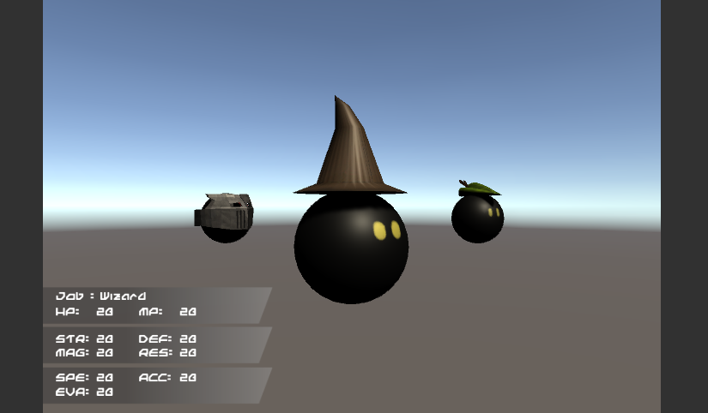

### Strategic Battle Formations

When the player is cruising through the character carousel they will be placing their characters within the available map locations. Much like chess they player will be forced to the one side of the map as this allows for tactical spacing between the two armies. The player will place all of their characters into a formation that best suits their battle type and proceed to play the game.

### Global Pointer

In game the most important element of control is the global pointer. This can be moved at any point within the game apart from when an AI is completing their turn. The global pointer allows the player to gain information about their own team as well as the opposition. Although it doesn’t show all the details is will display the characters health, mana and class type if moved to their position. Otherwise the global pointer is used to complete movements, actions and other important mechanics.

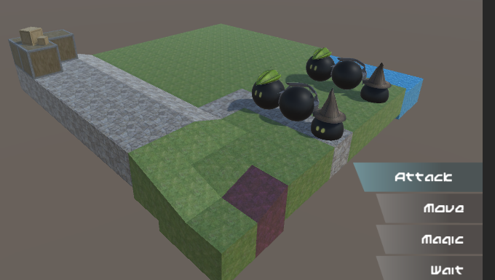

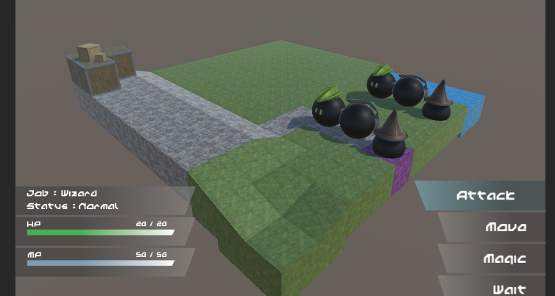

### Movement

When the players turn begins they have the option to move their characters. Moving the character is very important within the game as it allows the player to group, disband, advance or retreat in a battle scenario. The movement is completed based off of the characters speed value. This varies from character to character so makes it a very important aspect when choosing your starting team. The movement of a character is vital if they wish to engage in combat as not every character is able to attack from range. In fact very few of them are.

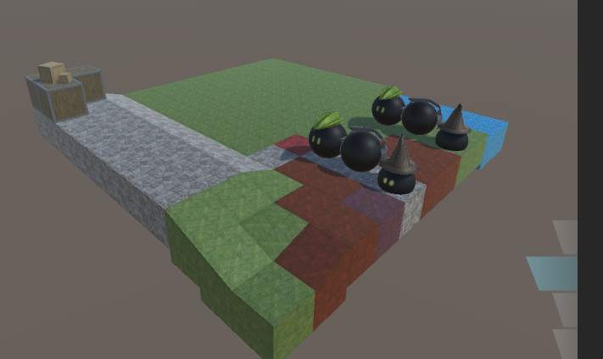

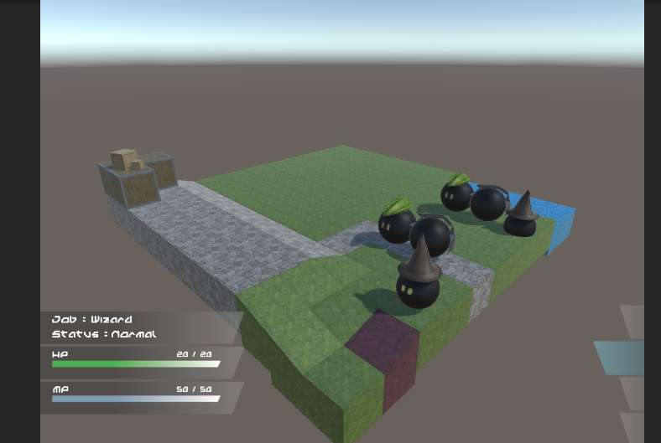

### Interactive UI

When playing a TBS game a large amount of the games focus is driven through the UI. This is because TBS games are fairly slow paced making it easy to manipulate game play with UI. If the UI is not interactive the game feels boring, slow and does not immerse the player. This is why it is very important to build a UI that is pleasing to use.

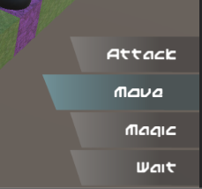 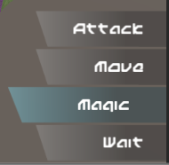  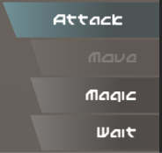

### Actions

Actions consist of five main options. Attacking, moving, spells, abilities and waiting. Each one of these options is what form a characters turn. They are able to complete two actions as long as one of them is movement. Using the actions to move around the map, attack the opposition or aid a friendly character are what make this game so exciting. All of the actions have been broken down into separate more detailed sections of the GDD.

## Target Platform

Although a lot of different platforms were considered the game is being targeted towards PC. This eliminates any need to tailor it to mobile and the thousands of different specs. The chosen platform allows the game to be built as a prototype for a larger scaled application, opposed to a polished game that would need serious testing and additional features if the target was console. Developing for PC means less focus on the games overall performance and more on the core game play. If the resources were available (Mainly time) the performance would be a greater concern.

## Project Scope

## Elevator Pitch

# Influences

## Worlds of Magic

http://myworldsofmagic.com/

A great thing about Worlds of Magic is that it was developed and created using Unity. Which is the game engine used to build Final Adventure. It is a simple yet very well executed game with very similar mechanics to the game created. Players work their way through a range of different battles fighting their way to victory and slowing exploring the world.

Worlds of Magic uses a map terrain that is very much alike the one used in Final adventure. Although it might have more to offer in terms of scenery the use of a square based environment is awesome.

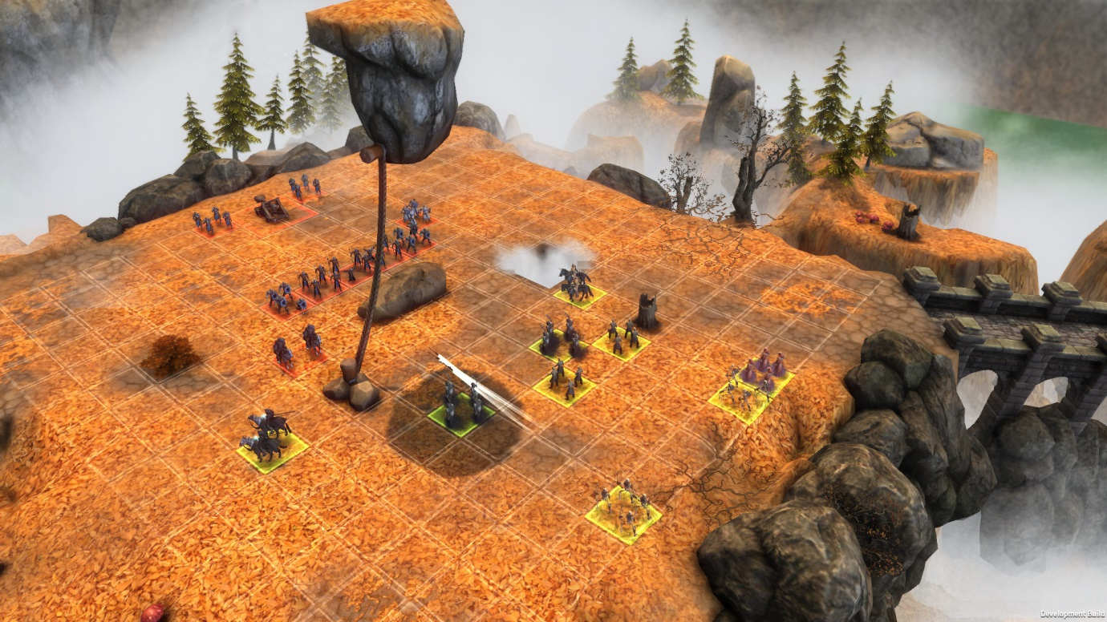

Something I really enjoy about Worlds of Magic is the out of range environment. It really brings the map together. It helps create a unique feel to all the different battle arenas. The angled view and open environments has been a key area of the game that has made an impact in how the camera view is used and the environment created for Final Adventure.

## Final Fantasy Tactics War of the Lions

A popular game with successful releases on mobile, PSP and PC. Tactics War of the Lions offers a humungous story line that truly is breath taking. With very challenging battles, this game can seem a little harsh but it really does bring out the true meaning to tactical warfare.

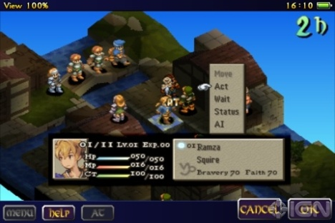

The simplistic environments and UI really help this game excel and act as such a strong inspiration towards the project in hand. I love the way the characters are manipulated around the map with the simple highlighted floor tiles. This has been a huge inspiration towards the controlling of the characters within the completed project.

## Warhammer 40,000 squad command

https://en.wikipedia.org/wiki/Warhammer_40,000:_Squad_Command

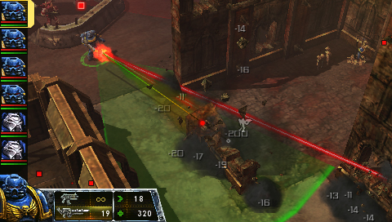

This game mimics the style of a table top game like dungeons and dragons. Giving the player a lot of freedom within their movement and attacking. The game uses very simple UI and strong map graphics considering it is originally a PSP game. Being able to see your team’s stats within the side of the map is very convenient as you know how you are doing overall. The attack range is clearly visible within the environment and the damage done is clearly displayed as the action takes place.

# Unique Selling Point (USP)

The USP of Final adventure is without a doubt the AI system in place. Without the AI the game would be another simple player vs player match up. This would be a great feature to apply within future development; however the challenge of creating an AI that will test the player is more appealing. Ensuring that the AI works and acts as expected is an important factor and can be seen as the make or break of the project.

When the AI is assessing it turn, it needs to find a target either on the opposition team to attack or on its own team to heal or aid in some way. This is what really makes the AI work as if it was human controlled. It assesses so many different aspects of the game to ensure it is making a decision that will benefit it within the future of the game.

Along with its decision making, the assessment it makes of the opposition is also key. The AI technique used is based on the Bayesian probability system. This is where the AI tries to predict the human’s actions and these probabilities will play a massive factor in what they decide to do.

However putting all the eggs in to one basket isn’t always the best thing to do. Because of this another selling point of the game is the simplicity of how it is played. Much like chess the player is very limited with what they can do with the characters. This forces the player to really think about what they are doing as each move is going to be extremely important.

# Development Objectives

|  |  |  |
| --- | --- | --- |
| MVP |  |  |
|  | Complete a competitor comparison | ✔ | |
|  | Analyse development weaknesses | ✔ | |
|  | Research and develop and AI system | ✔ | |
|  | Create an interactive UI | ✔ | |
|  | Learn to model and texture simple assets | ✔ | |
|  | Give the players a variety of characters | ✔ | |
|  | Make character unique with special traits | ✔ | |
|  | Create game that involves strategy tactics | ✔ | |

|  |  |  |
| --- | --- | --- |
| Additional |  |  |
|  | Integrate Learning AI | ✔ | |
|  | Create levelling system to allow in game progression |  | |
|  | Offer a set of environments to play in |  | |

# Story

In the games current state there is no story line in place. This however is defiantly an area in which further development will focus on. The need for an AI system that works well is more important that a story line in its current development state. Now the AI is complete, it might require a few adjustments but the main bulk of it is complete. With the finished AI the game will be able to generate several different maps, AI scenarios and mould it around a story line to engage the player even more.

Much like the FF Tactics War of the Lions game I would love for the game to have an in depth story line that involves the user. This will act as the inspiration for the next steps of the story development.

# Characters

In the games current state there are only five different characters to choose from. The main reason behind this is because the player must choose a set of five characters and I wanted there to be the option for five different characters. The structure of the game has been made so it can easily implement more characters with new unique strengths and weaknesses, however the need for more models and textures is holding this up. The models used are very basic and handmade, but if the game was to expand to more characters I would like to revise their models or outsource it to a client. This would ensure that is it made to my own specification.

## Archer

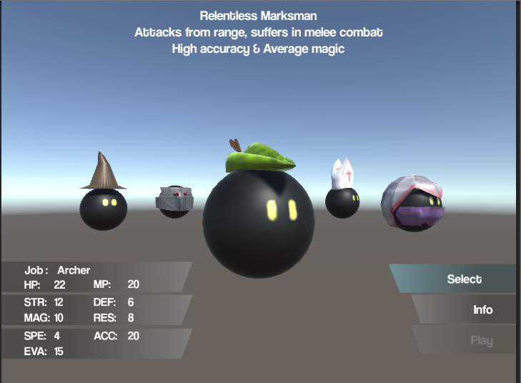

The only ranged character within the game. Able to attack enemies from a distance but not able to do any damage within melee range. The Archer has average stats, however they have high accuracy and evasion. This allows them to almost always hit their target, and a higher chance to dodge an attack. The use of a ‘Robin hood’ hat to resemble the character.

## Wizard

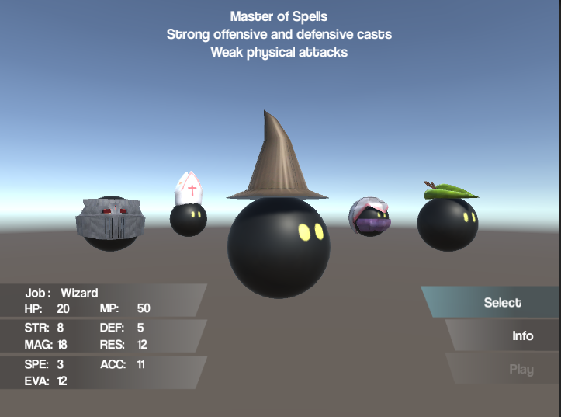

The wizard offers high damage offensive spells as well as a strong heal for allies. Very weak in terms of physical damage and defence. The high mana pool allows the wizard to cast a lot of spells before resorting to the less effective attacks. Doesn’t have much health so best to attack with magic and then retreat to a safer distance. Using a traditional wizard hat as its trademark look.

## Assassin

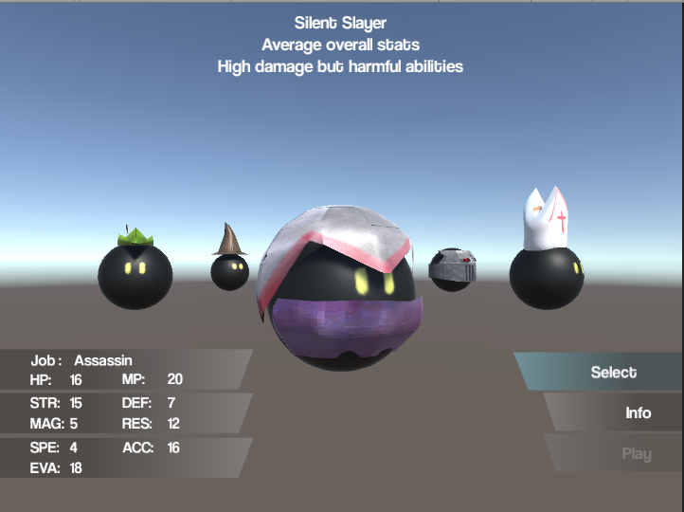

The assassin is my personal favourite in terms of utility. All of its stats are either very strong or weak, allowing for some interesting play types. The assassins abilities are more situational that anything e.g. assassinate is stronger the lower the targets health, blood blade damages for a lot but also hurts the assassin in return. The look for the assassin is based off the assassins creed characters with a white hood and cloth mask. Very hard to model a sphere character with a hood so is one I would like to revisit.

## Priest

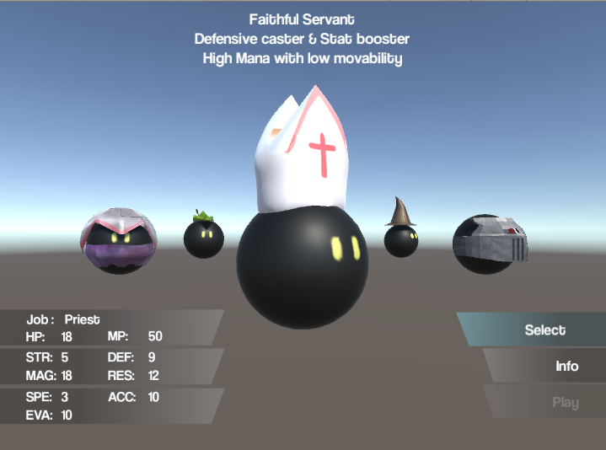

The priest was the newest addition to the game and inspired due to the lack of magic based characters. Much like the wizard its strengths lay within magic but more defensive that offensive. Used to heal and mend ally characters than deal damage to the opposition. A priest is great for keeping your characters healthy within battle. Has a pope styled hat with a cross on, to show that he is more peaceful that the other characters.

## Warrior

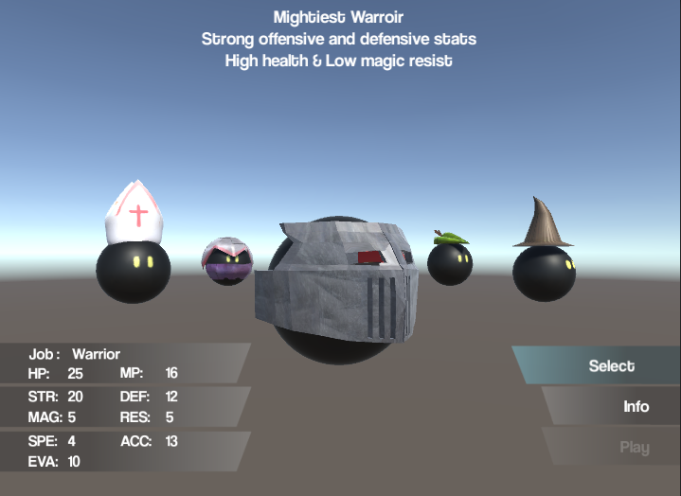

Finally the warrior! Although the helmet looks like the front of a train it is meant to be a helmet. Although the thought of an oncoming train is just as scary. Again a very tricky character to model as a traditional medieval helmet would cover the entire character. The warrior’s strengths lay with its high health pool and physical attacks. Used as a front line man to absorb damage, yet the power to deal it back if needed.

# Spells & Abilities

## Heal

Available to every character however it is not very useful to characters without a high magic stat. Using mana to heal a character within a close range.

## Flare

A fire based spell used and effective against all character types. Available to the wizard and priest only.

## Wind

A tornado of fury cast by only a wizard, effective against all character types.

## Slash

A strong physical based attack used by the warrior. Stronger than a normal physical attack but uses up a large amount of mana, needs to be used wisely.

## Focus

The archers main source of power. Increased the accurate stat and deals a high amount of damage to characters with low defence.

## Assassinate

The assassins main attack, used to deal more damage based on the characters health lost. The more health lost the stronger the attack.

## BloodBlade

Another assassin based ability used to deal strength based damage onto an enemy at the price of being damaged itself.

# Level

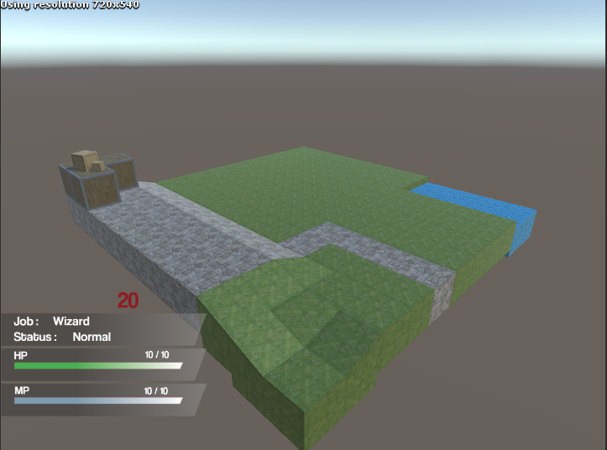

The only level currently available for the game is this grass 10 by 10 map. In the future more maps and environments will be created but the need for 3d assets is too high and the reason the level design wasn’t considered an important aspect. There are a lot more textures ready to be used, however they are going to be used to create different locations.

Ideally the future maps will consist of more complex environments (not 10 by 10). Making them bigger more complex to get around and other aspects will be interesting to explore. The aim of the current map was to redefine the chess board with a more artist feel. The map was also created in the level editor of Unity so would need reworking to make it more dynamic as this would allow the map to be created programmatically. The map needed to be simple much like the Worlds of Magic maps as the UI and surrounding elements are also simplistic. Overloading the map with too much could cause distraction. When a story line is put into place, the maps will be created to compliment it, bringing the visual aspect to back up the story.

# Art

Not much art has been used for this game, the UI is very basic and only uses a gradient based shape with simple text. The only bit of art used for the game is the main menu which consists of a map, burnt compass and text.

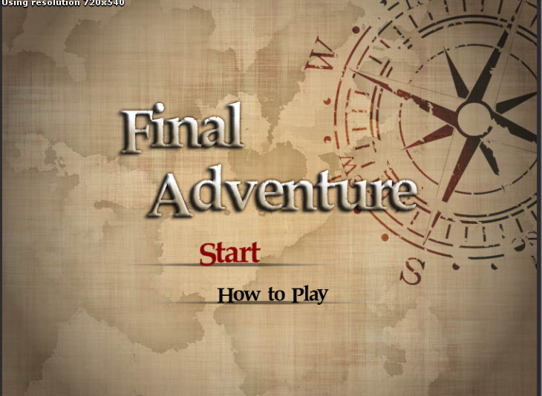

This was the only art made for the project, the rest is 3d models and their corresponding textures.

# Sound

Sound is a difficult source to create without a large amount of experience in creating it. Finding free or outsourcing the sounds of the game could prove to be a key, making the game more immersive.

<http://www.bfxr.net/>

Resources like BFXR could be used to create noises and sounds that go alongside the character actions.

So far the resource above has been used to create the sounds for all spells, attacking and death.

# Controls

The focus for the Final Adventure was to bring all of the controls to the one piece of hardware. The chosen piece of kit was the keyboard, although using a PlayStation or Xbox controller would have been just as effective, anyone who plays the game will always have access to a keyboard and is the reason behind it. The controls revolve around two, four directional movement combos. These being the arrows keys and the traditional W, A, S and D. For the most part the arrow keys are used with the menu, scrolling up and down the options, accompanied by the return key to select and the right shift to go back in the menu. Whereas the WASD combo is used to manipulate the in game pointer around the map. These are the only controls within the game, making it easy to remember and there is no need to move your hands away from the required sections of the keyboard.

Command an army through combat situations

Use the left and right arrow keys to rotate the character carousel

Use the Up and Down arrow keys to move through the side menu choices

Use the W, A, S and D keys to move the character around the available positions

If the position is taken - Enter will remove the character from that positon

Completing a turn

A turn consists of an actions and a movement

An action can be either offensive or defensive

Some actions require mana to cast or perform